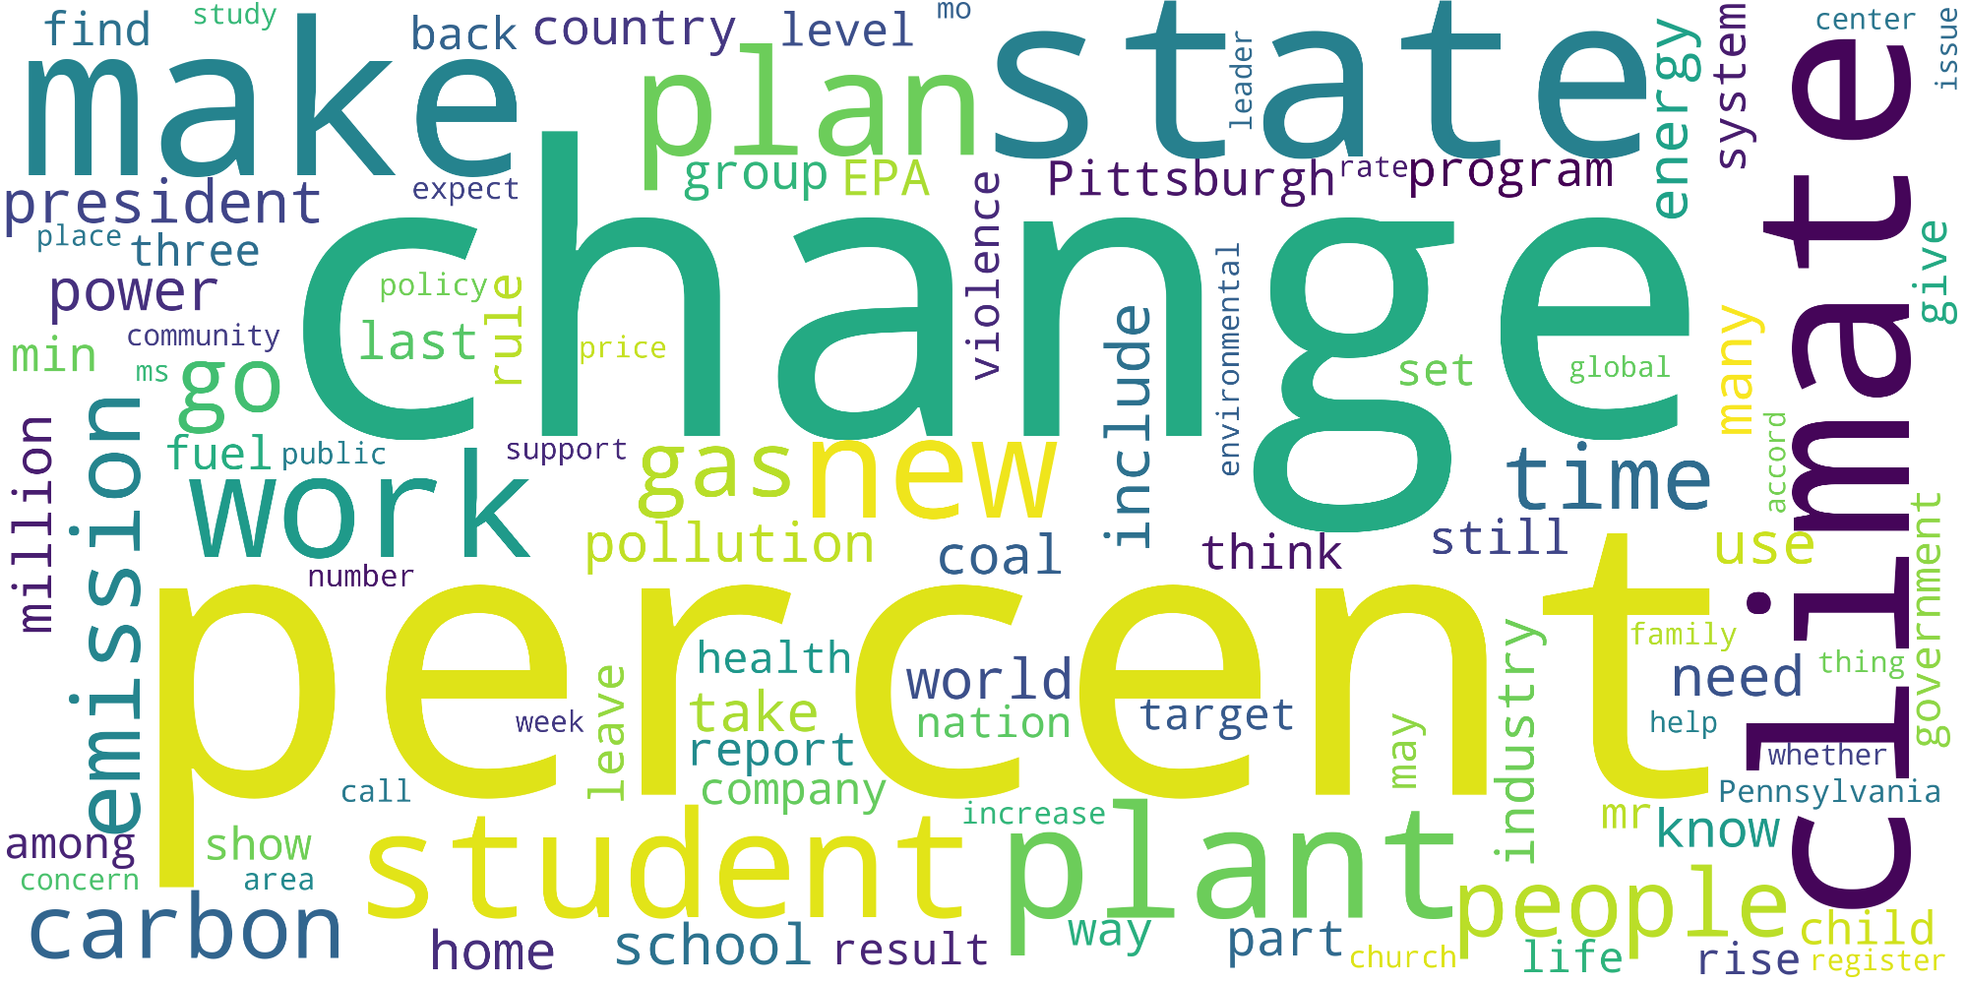

find study

center

back country_level "

leader

issue

make planştate.

energy

system

expect

group EPĀ.

Pittsburgh rateprogram

place three

president

power min community

policy last'

violence

give

change

ms O

environmental

set

global

include

many

fuel public

support

gasn pollution

time

use

accord

climate

coal

think

still

million emission

number

family

government

need thing o

week

leave

health

world take

nation report company

increase

target

may

industry

help

whether Pennsylvania

call

mr know

among

show

concern

area

carbon

home school result

way

ople part church P life

child rise register